**Project report template**

**IMPLEMENTING CRM FOR RESULT TRACKLY OF A CANDIDATE WITH INTERNAL MARKS**

# **INTRODUCTION**

* Administrator should be able to create all base data including Semester, Candidate, Course and Lecturer.
* Lecturer should have the ability to create Internal Results.
* Dean, who is one of the Lecturer, should be the only one with ability to update Internal Results, Revaluation Can be initialized by Candidate for all Internal Results.
* Now only dean can update the marks after re-evaluation.

# **EMPATHY MAP**

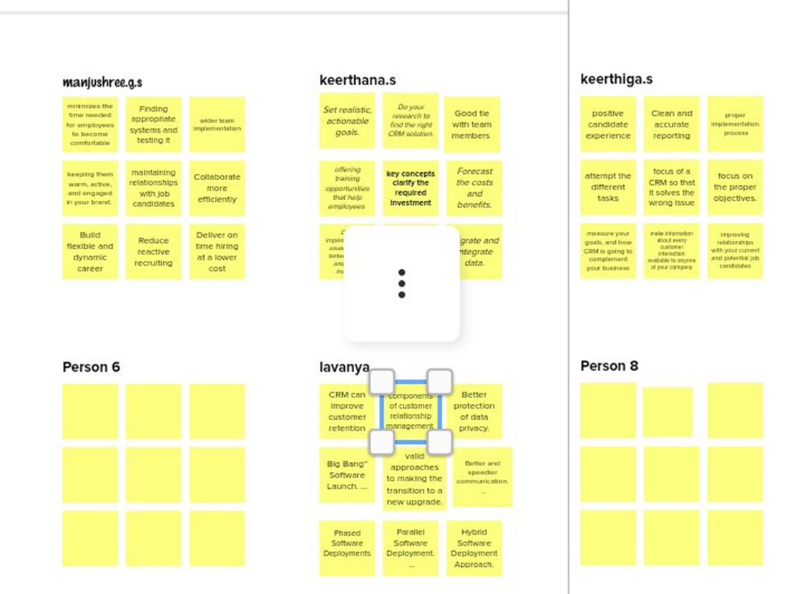

# **IDEATION AND BRAIN STORMING**

* Brainstorming has remained the cornerstone of the creative industry for decades and has evolved over the years as experience and learning developed from its variety of applications.
* Brainstorming stimulates the building of ideas by a process of association. Embrace the most out-of-the-box notions and build, build, build. Be positive and build on the ideas of others.

# **RESULT**

* A CRM platform is an overarching system overhaul, and the scale and detail of its implementation must match its intended reach.
* These six key concepts clarify the required investment and strategies businesses can follow for a successful CRM implementation process.

# **DATA MODEL - SALESFORCE DEVELOPER**

* OBJECT NAME AND FIELDS IN OBJECT
* OBJECT 1 - SEMESTER
* OBJECT 2 - COURSE DETAILS
* OBJECT 3 - CANDIDATE
* OBJECT 4 - INTERNAL MARKS
* OBJECT 5 - LECTURER DETAILS

## **MILESTONE 1 - OBJECT AND FIELDS AND RELATIONSHIP**

* WE CREATED IN FIRST TASK 1 SALESFORCE OBJECTS ARE DATABASE

TABLES THAT PERMIT ME TTO STORE DATA THAT IS SPECIFIC TO AN ORGANISATON.

* IN TASK 2 WE DONE TWO WAY ASSOCIATION BETWEEN TWOOBJECTS. RELATIONSHIPS ARE CREATED BY CREATING CUSTOM RELATIOSHIP FIEDSON AN OBJECT.
* IN TASK 3 WE CREATED NEW LIGHTENING APP IN THE APP

MANAGER AND ENTERED WE WANTED PROFILE SUBJECTS

# **MILESTONE 2 - APP MANAGER**

* IN TASK 4 WE CREATED USER PROFILE IN OUR TEM WE INDIDUALLYCREATED UER PROFILE BY ENTERING SALESFORCE ADMINISTER IN MY PROFILE.
* IN TASK 5 WE CREATED REPORTS BY ROWS AND COLOUMNS INDISPLAYED CHART.
* IN TASK 6 WE CREATED DASHBOARDS FROM THE REPORT TAB .THENCUSTOMIZE OUR REPORT, THEN SAVE & RUN IT.

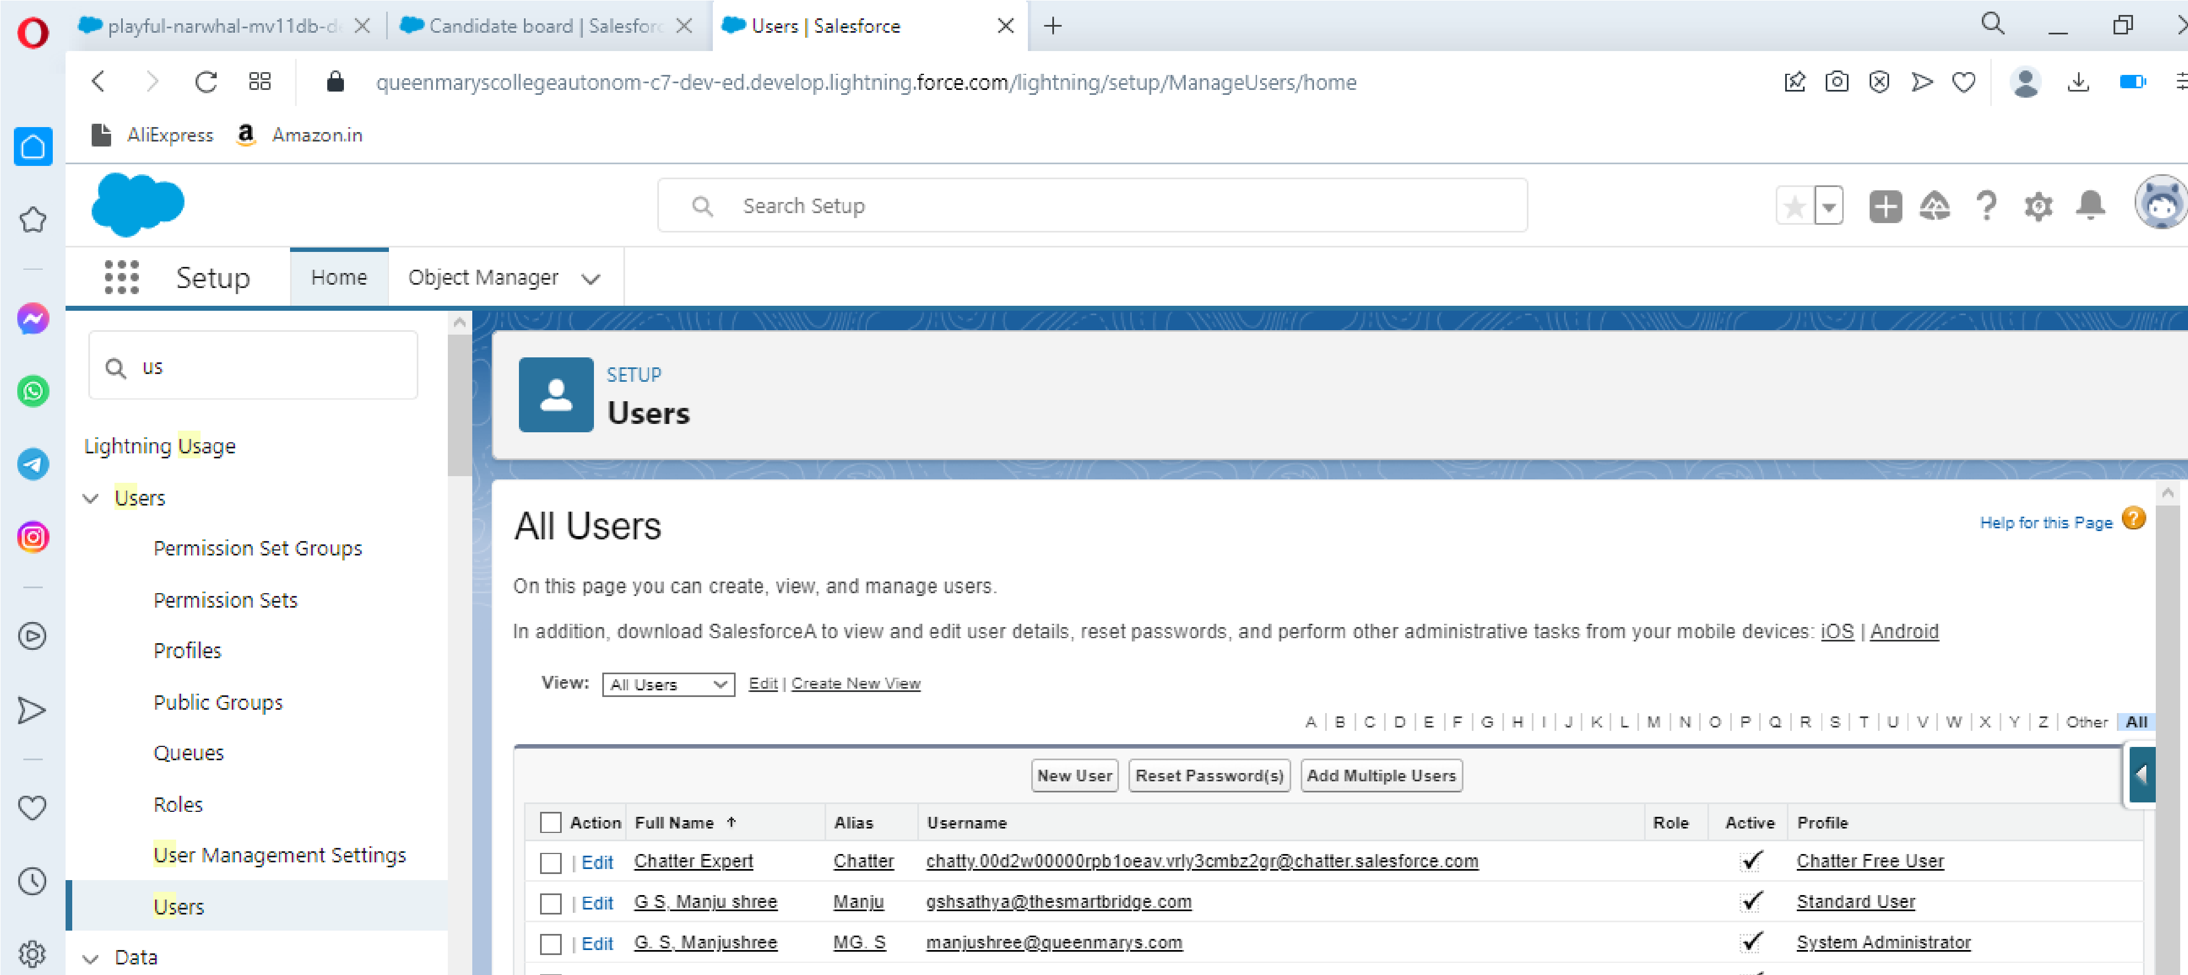**MILESTONE 3 - USERS**

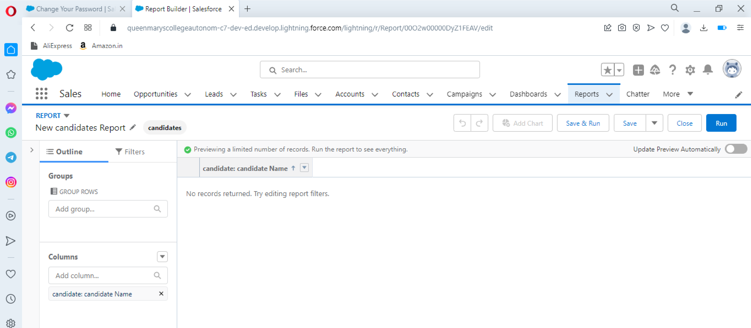**MILESTONE 4 - REPORTS**

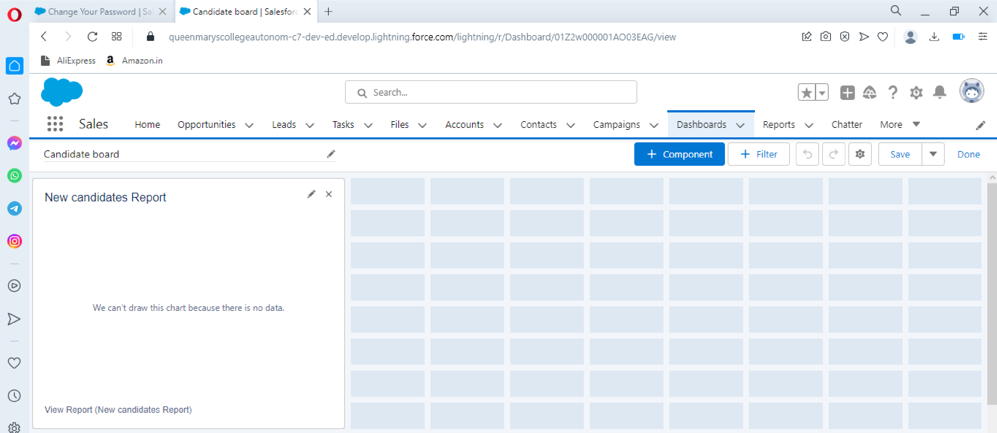**MILESTONE 5 - DASHBOARDS**

# **DESCRIPTION**

* CRM software can be a super great technology, but if it is industry agnostic, its implementation is destined to fail.
* In case you cannot find a solution that will entirely meet your market needs, you should look for highly customizable platforms like Salesforce. They allow modifications of all complexity levels to align completely with their customer requirements.

# **TRAILHEAD PROFILE PUBLIC URL**

TEAM LEADER-<https://trailblazer.me/id/pyamunas>

* TEAM MEMBER 1 - <https://trailblazer.me/id/psripriyas>
* TEAM MEMBER 2 - <https://trailblazer.me/id/psriparameswarij>
* TEAM MEMBER 3 - <https://trailblazer.me/id/tuthiri>